**FINAL PROJECT DOCUMENTATION**

**Online Quran Learning**



**Submitted By**

|  |  |
| --- | --- |
| Muhammad Awais Danish | 17-Arid-572 |
| Muhammad Bilal Chaudhary | 17-Arid-573 |
| Usama Bashir | 17-Arid-607 |

**Supervisor**

Ms Zainab Mehmood

Lecturer

2021

**Gujrat Institute of Management Sciences**  
**PMAS-Arid Agriculture University, Rawalpindi**

**Online Quran Learning**

Project submitted to

Department of Computer Science

Gujrat Institute of Management Sciences

**By**

|  |  |
| --- | --- |
| Muhammad Awais Danish | 17 - Arid - 572 |
| Muhammad Bilal Chaudhary | 17 - Arid - 573 |
| Usama Bashir | 17 - Arid - 607 |

In partial fulfillment of the requirements for the degree of

BSCS (Hons.)

**Gujrat Institute of Management Sciences**  
**PMAS-Arid Agriculture University, Rawalpindi**

**Members’ Detail**

|  |  |
| --- | --- |
| **Project ID** | GIMS-BSCS/201701 |

|  |  |  |  |
| --- | --- | --- | --- |
| Online Quran Learning | | | |
| **Group Leader:** Muhammad Awais Danish  **Group Members:**3 | | | |
| Name | Registration # | Email Address | Class |
| Muhammad Awais Danish | 17-Arid-572 | [mr.awaisdanish@gmail.com](mailto:mr.awaisdanish@gmail.com) | BSCS |
| Muhammad Bilal Chaudhary | 17-Arid-573 | [muhammadbilal17arid573@gmail.com](mailto:muhammadbilal17arid573@gmail.com) | BSCS |
| Usama Bashir | 17 - Arid - 607 | [uxama.ali775@gmail.com](mailto:uxama.ali775@gmail.com) | BSCS |

|  |  |
| --- | --- |
| **_____________________**  **Mr. Faizan ul Mustafa**  PMO || GIMS |  |

|  |
| --- |
| **Dated: _____________________** |

# Dedication

We dedicated this project to the people who wants to learn Quran but they are facing difficulties to go to the Masjid and are not veiling to arrange home tutors.

# Project Summary

|  |  |
| --- | --- |
| **Project Title** | Online Quran Learning |
| **Project ID** | GIMS-BSCS-F201701 |
| **Organization** | Gujrat Institute of Management Sciences |
| **Objective** | Objectives are as follow :   * To develop a website that would help users to learn the Quran according to their preferred language and time zone. * To help people to find the Quran tutor more efficiently and easily. * To increase the outreach of tutor to potential Quran learner. * To make learning the Quran easy for overseas Pakistani. * To promote Quran learning in all age group. |
| **Undertaken By** | Muhammad Awais Danish (17-Arid-572), Muhammad Bilal Chaudhary (17-Arid-573), and Usama Bashir (17-Arid-607) |
| **Supervised By** | Ms Zainab Mehmood |
| **Date started** | March 20, 2021 |
| **Date Completed** | July 08, 2021 |
| **Technologies Used** | VS Code , Laravel , Xamp, HTML , CSS , Bootstrap |
| **System Used** | Window 10 |

**Proofreading Certificate**

**This is to acknowledge that the project entitled**

Online Quran Learning **[**GIMS-BSCS-F201701**]**

**Has been proof**

**Read By**

**_____________________**

**Ms Zainab Mehmood**

Lecturer, Department of Computer Science / GIMS

|  |
| --- |
| **Dated: _____________________** |

# Declaration

We hereby declare that we developed this project and this report entirely on the basis of our personal efforts made under the sincere guidance of our project supervisor. We further declare that, the titled project and all associated documents, reports are submitted as partial requirements for the degree of “BS (Hons.) in Computer Sciences”.

|  |  |  |
| --- | --- | --- |
| **Members’ Name** | **Registration #** | **Signature** |
| Muhammad Awais Danish | 17-Arid-572 | _______________ |
| Muhammad Bilal Chaudhary | 17-Arid-573 | _______________ |
| Usama Bashir | 17-Arid-607 | _______________ |

**Dated:** __________________

# Acknowledgement

Up and above, everything, all appreciation to Allah Almighty, the kind and merciful, Who enabled us to reveal a drop from the existing ocean of knowledge, countless greeting be upon the Holy Prophet Muhammad (Sallallaho Alaihe wa Aalehi Wassalam), the city of knowledge, Who has guided our “Ummah” to seek knowledge from cradle to grave. We truly acknowledge the cooperation and help make by Project Management Office, CS & IT department, GIMS. He has been a constant source of guidance throughout the course of this project. It is quite enjoyable and to becoming to avail of this most promising opportunity to clear with highest gratification, our profound and intense sense if obligation to our affectionate supervisor, Miss Zainab Mehmood, Lecturer Gujrat Institute of Management Sciences, Pakistan. Their proficient counseling, valuable suggestions, boundless patience, untiring help with anything, anywhere, anytime, perfect advice and thought-provoking instruction in piloting this project.

**Certificate**

This is to certify that **Muhammad Awais Danish**, 17-Arid-572 , **Muhammad Bilal Chaudhary**, 17-Arid-573 , and **Usama Bashir**,17-Arid-607 have successfully completed the final project titled: “Online Quran Learning”, accepted by the Department of Computer Science and find satisfactory for the requirement of:

**Gujrat Institute of Management Sciences**

**PMAS-Arid Agriculture University Rawalpindi**

**For Award of the Degree**

**BS ( HONS ) in Computer Science**

|  |  |  |
| --- | --- | --- |
|  | ________________  Supervisor  Ms Zainab Mehmood  Lecturer, GIMS |  |
|  | ________________  Examiner 1  Mr. / MS. XYZ  Designation, GIMS |  |
|  | ________________  Examiner 2  Mr. / MS. XYZ  Designation, GIMS |  |
|  | ________________  Examiner 3  Mr. / MS. XYZ  Designation, GIMS |  |
| ________________  HOD/CS-IT  GIMS |  | ________________  Director General  GIMS |

**Dated:** ___________________

# Abstract

Learning the Quran is part of our religious responsibilities. In the past, children go to their near masjids to learn Quran and complete it in childhood. These people are getting older and they have not completed their Quran learning. Many people are not able to manage their time due to time constraints. Some people have an interest and they want to learn Quran (tajweed, translation, hifz and kirat etc), but they don’t get a proper tutor. Many Muslim people from Pakistan are settled in Europe and they want to learn Quran from Pakistani Quran teachers. These observations inspired us to start this project to make the Quran easy to learn and to serve our religion. Learning Quran Online is a proposed project where finding a student or teacher would not be difficult and people will be able to get a teacher according to their time zone. Learners can learn the Quran based on their preference of learning and enroll themselves for tajweed, translation, hifz and kirat etc. Female tutors will be available for females. There will be no software needed to download, you just need to login and enjoy learning. You will be able to learn the Quran in your native language. Your kids will be in a safe environment of learning.

# Table of Contents

Dedication iii

Project Summary iv

Declaration vi

Acknowledgement vii

Abstract ix

Table of Contents x

List of Tables xiii

List of Figures xiv

List of Abbreviations xv

Chapter 1 Introduction 2

1.1 Problem Background 2

1.2 Problem Statement 3

1.3 Significance 3

1.4 Objectives 3

1.5 Limitations and Restrictions: 4

1.6 System Architecture 4

1.7 Software/Hardware Requirements 5

1.8 Implementation Tools and Technology 5

1.9 Implementation Plan 5

1.9.1 Deliverable Items 5

1.9.2 Milestone Chart 6

1.10 Overview 6

Chapter 2 Requirement Analysis 9

2.1 Functional Requirements 9

2.2 Non Functional Requirement 12

2.3 Use Cases 13

2.3.1 Use Case for Sign Up As Learner 13

2.3.2 Use Case for Login 14

2.3.3 Use Case for Forget Password 15

2.3.4 Use Case for View Profile 16

2.3.5 Use Case for Edit Profile 16

2.3.6 Use Case for Search Course 17

2.3.7 Use Case for Enroll For Course 18

2.3.8 Use Case for Leave Course 19

2.3.9 Use Case for Book a Demo Class 20

2.3.10 Use Case for Find Tutor 21

2.3.11 Use Case for Upload Payment Receipts 21

2.3.12 Use Case for View payment History 22

2.3.13 Use Case for Chat with Tutor 23

2.3.14 Use Case for Sign Up As Tutor 23

2.3.15 Use Case for Add Course 24

2.3.16 Use Case for Remove Course 25

2.3.17 Use Case for View Enrolled Learners 26

2.3.18 Use Case for Find Learner 26

2.3.19 Use Case for Accept Invitation 27

2.3.20 Use Case for Reject Invitation 28

2.3.21 Use Case for Upload Learning Material 29

2.3.22 Use Case for Remove Learning Material 29

2.3.23 Use Case for Chat with Learner 30

2.3.24 Use Case for Add Announcement 31

2.3.25 Use Case for Remove Announcement 31

2.3.26 Use Case for Search Tutor 32

2.3.27 Use Case for View Tutor Profile 32

2.3.28 Use Case for Deactivate Tutor Account 33

2.3.29 Use Case for Chat with Tutor 34

2.3.30 Use Case for Search Learners 35

2.3.31 Use Case for View Learner Profile 35

2.3.32 Use Case for Deactivate Learner Account 36

Chapter 3 DESIGN 39

3.1 UML Diagrams 39

3.2 Class Diagram 42

3.3 Sequence Diagram 43

3.3.1 SignUP 43

3.4 ERD 50

Chapter 4 Testing 52

4.1 Sign Up Admin 52

Chapter 5 User Manual 58

5.1 Home Page 58

# List of Tables

Table ‎2.1: Use-Case to Signup as Learner 13

Table ‎2.11: Use-Case to Upload Payment Receipts 21

Table ‎2.12: Use-Case to View payment History 22

Table ‎2.14: Use-Case to Chat with Tutor 23

Table ‎2.15: Use-Case to Sign Up As Tutor 23

Table ‎2.16: Use-Case to Add Course 24

Table ‎2.17: Use-Case to Remove Course 25

Table ‎2.18: Use-Case to View Enrolled Learners 26

Table ‎2.19: Use-Case to Find Learner 26

Table ‎4.1: Sign up Test case 52

# List of Figures

Figure 1.1: Model-View-Controller 8

Figure 1.2: Gantt chart for milestones 10

Figure 3.1: Use-Case Diagram for SMP 19

Figure 3.2: Use-Case Diagram for Admin 20

Figure 3.3 Class Diagram 21

Figure 3.4: Sequence Diagram for User Authentication 22

Figure 3.5: ERD of HMP 23

Figure 5.1: Home Page 27

Chapter 1

Introduction

# Introduction

Learning Quran is the part of our religious culture. In the past, children go to their near Masjids to learn Quran and complete it in childhood. Now a days, people are getting older and they have not completed their Quran learning. Now people have less interest in learning the Quran and they have much attention towards other things. These observations inspired us to start this project to make the Quran easy to learn and to serve our religion.

Many people are not able to manage their time due to time constraints. Some people have an interest and they want to learn Quran (tajweed, translation, hifz and kirat etc), but they don’t get a proper tutor. Some families have to move to other cities. Whenever they move to another city they get a new tutor and the tutor teaches them the basics of the Quran. Many Muslim people from Pakistan are settled in Europe and they want to learn Quran from Pakistani Quran teachers. People search for an online tutor from different social media platforms where they face a lot of difficulties to get a tutor.

You can easily find a tutor according to your time zone. The people who want to learn Quran (tajweed, translation, hifz and Kirat etc), will get a proper tutor of that. The people who have to move to other cities due to their reasons, will not need to change tutors. They can study with the same teacher. The Muslim families which live in Europe can easily find and learn Quran from Pakistani teachers. People won’t face difficulties in searching for a tutor.

## Problem Background

People used to go to masjid for learning Quran in the past. As time changes, people started calling the Quran teacher to their homes to teach them the Quran. Many people want to learn Quran with proper manners like tajweed, translation, hifz and kirat etc, but they don’t get a proper tutor to fulfill their needs. Now the time has changed, many people prefer to learn online Quran. Many Muslim people from Pakistan are settled in Europe and they want to learn Quran from Pakistani Quran teachers. People search for an online tutor from different social media platforms where tutors post an advertisement. When they get a tutor to teach, then they learn through video calls on different social media platforms.

## Problem Statement

Recently, there has been a great interest in Islamic software that try to harness computer to serve the religion. However, these computer-programs, especially those developed for the sake of the noble Quran are still limited. Quran Learner and tutor remain vigilant to face the challenges of change by employing new technology in Holy Quran learning. To add a significant contribution to serving Islam and helping others in the learning process there is a need for a software system where learners and tutors can learn Quran.

## Significance

The Online Quran Learning provides facilities to a common user in learning and teaching and it helps our community to learn hifz, tajweeed, etc. The Online Quran Learning provides facilities to make it possible for the learners and teachers to find each other on this platform. Moreover, it provides user friendly and attractive interface with 24/7 rental service.

## Objectives

The objectives are:

* To develop a website that would help users to learn the Quran according to their preferred language and time zone
* To help people to find the Quran tutor more efficiently and easily.
* To increase the outreach of tutor to potential Quran learner
* To make learning the Quran easy for overseas Pakistani
* To promote Quran learning in all age group

## Limitations and Restrictions:

This website will not allow the tutor to do online streaming of a class. The learner cannot pay his course fee through this website as no payment gateway will be integrated into the website.

## System Architecture

|  |
| --- |
| arc2 |

Figure ‎1.1: System Architecture

## Software/Hardware Requirements

The system can be run on any kind of device not only on pcs, but on android or iOS devices also. The only requirement needed to run the website will be a web browser like Google Chrome, Mozilla Firefox, etc.

## Implementation Tools and Technology

* Hosting Server
* Apache Server or Xampp
* MYSQL Server or Xampp
* PHP Laravel
* VS Code
* MYSQL

## Implementation Plan

### Deliverable Items

* + Project Proposal
  + Software Requirement Specification (SRS)
  + Project Presentation and Final Documentation
  + Executable Files
  + CD
  + User manual

### Milestone Chart

|  |
| --- |
| Screenshot 2020-12-02 210956 |

Figure ‎1.2: Gantt chart for milestones

## Overview

|  |
| --- |
| **Project Goal:**  To develop a website that would help users to learn the Quran according to their needs. Help them to learn Quran More efficiently and easily.  In this way, the students will learn Quran in an organized way without any time restrictions. This will increase student’s interest to our religious culture and they learn more about Islam. |
| **Type of project:** 📺R&D 📺Development |
| **Project Success criteria:**  This website helps the user to find a tutor or a student to teach and learn. The project is supposed to be succeeded if it actually helps the users not to face the problems like time constraints, getting proper teacher according to needs etc. The success of the project is dependent with the performance of the project |
| Risks of the Project:  |  |  |  |  | | --- | --- | --- | --- | | **(Please mark 🗹 where applicable)** | **Low** | **Medium** | **High** | | Technical risk | **🗹** | ❑ | ❑ | | Timing risk | **🗹** | ❑ | ❑ | | Budget risk | **🗹** | ❑ | ❑ | |
| Organization Details (if any): None |
| **Target End users:**   * People who want to Learn Quran. * People who want to Teach Quran. |
| **Development Technology/ Languages:**   * PHP * HTML , CSS , BOOTSTRAP * MYSQL * XAMP Server * LARAVEL 8 * VS CODE |
| **Platform:**  **☑**Web based 📺Distributed 📺Setup Configurations  📺Desktop based 📺Android 📺iOS  📺Other_____________________ |
| **Project Supervisor:** Ms. Zainab Mahmood |

Chapter 2

Requirement Analysis

# Requirement Analysis

## Functional Requirements

**Learner Module**

1. **Registration**

* Sign up
* Login

For registration user is required to provide, email password, and retype the password and phone number. The user who has not registered cannot book a lecture.

1. **Profile View and Edit Profile**

The registered user can view profile information.

**Edit Profile:** The user can change his password and his phone number whenever it is necessary.

1. **Course**

* Search Courses
* Enroll for Course
* Leave Course
* Book a Demo Class

Learner can search for their interested course. If it is interested to him/her. They can enroll for it. They can take a demo class to check either they are being satisfied with the teacher and course or they are not. For some reason, if he/she wants to leave the course, they can leave it.

1. **Payment for Course**

* Upload Payment Receipts
* View Payment History

There will be transaction system in our website. User can pay by any method which is easy to them. Such as bank transfer, easy paisa, jazz cash etc. After payment, user must upload a scanned image of receipt. And they can view their payment history.

1. **Find Tutor**

The registered tutors who have created their profiles can be searched.

If a learner wants to find tutor, he/she can see their gigs and he can search tutor by name.

1. **Chat with Tutor**

Learner can chat with tutor for booking a course and in case of any query or for asking questions related to their course.

**Tutor Module**

1. **Registration**

* Signup
* Login

For registration tutor is required to provide, email password, and retype the password and phone number. If he/she wants to teach using our platform, then they must sign up and login for it.

1. **Quran Course**

* Add course
* Remove course
* View Enrolled Learner

Teacher can add new courses which he/she wants to teach. After adding new courses, if he/she wants to update something, he/she can modify it. Teacher can view enrolled students, for some reasons if he/she does not want to teach, he/she can remove that course.

1. **Profile**

* View Profile
* Edit Profile

The registered tutor can view profile information.

**Edit Profile:** The tutor can change his password and his phone number whenever it is necessary.

1. **Find Learner**

The registered users who have created their profiles can be searched.

If a tutor wants to find learners, he/she can see their profiles who have created their accounts.

1. **Schedule**

* Add Schedule
* Update Schedule

Tutor can add schedule according to his/her time zone. In case he/she wants to update time schedule, he can modify it.

1. **Demo Invitation**

* Accept invitation
* Reject invitation

If a learner requests a teacher for a demo class then teacher has the authority to accept or reject their invitations.

1. **Chat with Learner**

A tutor can respond to the messages of learners. If a tutor find some learners through “Find learners feature”, he can contact with them.

1. **Learning Material**

* Upload Learning Material
* Remove Learning Material

Teacher can upload learning material for the learners. In case teacher wants to modify learning material, he can edit it.

For some reason, if a teacher wants to remove some material, he can remove it.

**Admin Module**

1. **Login**

Admin can login to the website to use his/her administrative authority.

1. **Learner**

* Search
* Profile view
* Deactivate Account

Admin can search and view the profiles of all learners. In case, he/she wants to delete account of a learner he can deactivate it.

1. **Tutor**

* Search Tutor
* Profile view
* Deactivate Account

Admin can search and view the profiles of all tutors including their profile’s ratings. In case, he/she wants to delete account of a tutor he can deactivate it.

1. **Chat with Tutor**

If an admin has something to tell or notify, he can chat with tutor.

## Non Functional Requirement

* **Usability**

We design a user-friendly interface for the people to learn the Quran so that they properly learn the Quran.

* **Performance**

We are developing a website that shows the teachers who want to teach and students who want to learn. This website helps both of them to easily find each other to teach and to study according to their time zones.

* **Design constraints**

On the main page of the website, users will see the option of Find a tutor and Find student. Then they can contact each other by simply creating an account to enjoy learning.

* **Scalability**

We provide a website for learning Quran, if some children are not able to go Masjids for learning because of their time constraints, they can learn Quran online by sitting home according to their time zone.

* **Secure**

We will provide a safe and secure environment for everyone to teach and learn Quran.

## Use Cases

### Use Case for Sign Up As Learner

Table ‎2.1: Use-Case to Signup as Learner

|  |  |
| --- | --- |
| **Name :** | Sign Up As Learner |
| **Primary Actor:** | Learner |
| **Precondition:** | Learner must have selected “ Sign up as Learner” option  Learner is at the registration screen  Learner have valid email |
| **Postcondition:** | Learner register successfully |
| **Trigger:** | Learner requests for registration. |
| **Main Success Scenario:** | 1. Learner enters name, email, password and confirm password and then press on submit button. 2. System verifies data entered by learner into system. 3. System presents a screen showing success message along with notifying that account activation link is send to your email which you need to confirm to activate your account. 4. Learner indicate the email confirmation. 5. System redirects learner to login screen. |
| **Extensions (Error Scenarios):** | 1. Learner leave some field empty. 2. Learner selects signup as tutor option instead of sign up learner. 3. Password & Confirm Password do not match. 4. Account with this email has already been created. |
| **System Response:** | 1.1 The Field could not be empty.  3.2 Password must be same.  4.1 Email already exists. |
| **Variations (Alternative Scenarios)** | None |

### Use Case for Login

Table ‎2.2: Use-Case to Login

|  |  |
| --- | --- |
| **Name :** | Login |
| **Primary Actor:** | User |
| **Precondition:** | Learner or Tutor is already registered.  Learner, Tutor and Admin must be on login screen. |
| **Postcondition:** | Learner, Tutor and Admin login successfully. |
| **Trigger:** | Learner, Tutor and Admin want to login into system. |
| **Main Success Scenario:** | 1. User enters email and password. 2. System verifies data entered by applicant. 3. System redirects the users to their respective dashboard/panel page. |
| **System Response:** | * 1. Login Successfully. |
| **Extensions (Error Scenarios):** | 1. User leave one of the field empty. 2. User enters wrong email. 3. User enters wrong password. |
| **Variations (Alternative Scenarios)** | None |

### Use Case for Forget Password

Table ‎2.3: Use-Case to Forget Password

|  |  |
| --- | --- |
| **Name :** | Forget Password |
| **Primary Actor:** | User |
| **Precondition:** | User is already registered.  User must be on login screen where forgot password is available. |
| **Postcondition:** | User reset Password successfully. |
| **Trigger:** | User current password seems incorrect |
| **Main Success Scenario:** | 1. User enters his email address or phone. 2. System verifies user email or phone. 3. System sends a verification code to their email or phone. 4. User enters the verification code. 5. System verifies the code and redirect the update password form page on system. 6. User enters new password and confirm password input fields and then click on submit. 7. Password updated. |
| **System Response:** | System response with success message that password updated. |
| **Extensions (Error Scenarios):** | * 1. User enters wrong email or phone.   2.1. User enters wrong verification code.  3.1. User enters different password in new password and confirm password input field.  4.1. Verification code not received to user |
| **Variations (Alternative Scenarios)** | None |

### Use Case for View Profile

Table ‎2.4: Use-Case to View Profile

|  |  |
| --- | --- |
| **Name :** | View Profile |
| **Primary Actor:** | User |
| **Precondition:** | Must have logged into the system. |
| **Post condition:** | View profile successfully. |
| **Trigger:** | Learner, Tutor requests to view his profile. |
| **Main Success Scenario:** | 1. User clicks on View Profile. 2. System redirects the respective profile page. 3. User view his profile. |
| **System Response:** | User view his profile. |
| **Extensions (Error Scenarios):** | 1.1 System does not redirect to view profile page |
| **Variations (Alternative Scenarios)** | None |

### Use Case for Edit Profile

Table ‎2.5: Use-Case to Edit Profile

|  |  |
| --- | --- |
| **Name :** | Edit Profile |
| **Primary Actor:** | User |
| **Precondition:** | User has logged in. |
| **Postcondition:** | Information in Profile updated successfully. |
| **Trigger:** | User wants to update some information in his profile. |
| **Main Success Scenario:** | 1. User selects the edit profile option. 2. System redirects the user to his respective edit profile page. 3. User enters the information that he wants to update and hit save button. |
| **System Response:** | System response with success message of Profile is successfully updated. |
| **Extensions (Error Scenarios):** | Login session has expired.  User enters data in incorrect format. |
| **Variations (Alternative Scenarios)** | None |

### Use Case for Search Course

Table ‎2.6: Use-Case to Search Course

|  |  |
| --- | --- |
| **Name :** | Search Course |
| **Primary Actor:** | Learner |
| **Precondition:** | Open Online Quran Learning System |
| **Postcondition:** | Search Course Successfully. |
| **Trigger:** | Learner wants to search course. |
| **Main Success Scenario:** | 1. Learner clicks on search bar. 2. Selects his desired course from dropdown list, either he wants to learn Tajweed , Kirat , Translation , Hifz , or Recitation. 3. System shows the list of profiles of tutors who teach his selected course. |
| **System Response:** | System shows Profile of tutors eligible for the required course. |
| **Extensions (Error Scenarios):** | Searched course does not show. |
| **Variations (Alternative Scenarios)** | None |

### Use Case for Enroll For Course

Table ‎2.7: Use-Case to Enroll for Course

|  |  |
| --- | --- |
| **Name :** | Enroll for Course |
| **Primary Actor:** | Learner |
| **Precondition:** | Must be logged in to enroll for the course |
| **Postcondition:** | Enrolled for Course Successfully. |
| **Trigger:** | Learner wants to enrol for the course. |
| **Main Success Scenario:** | 1. Learner searches for his desired course. 2. System shows the list of gigs of tutors who teach his selected course. 3. Leaner chooses a tutor of his choice and open his gig. 4. Clicks on Enrol button. 5. System shows a form having details of course like course duration, class schedule and course fee. 6. Learner clicks agree. 7. Enrolled Successfully. |
| **System Response:** | System response with a success message of Enrolment Request Sent and upload fee payment receipt to access the course material and class link. |
| **Extensions (Error Scenarios):** | Enrollment request is not being sent successfully. |
| **Variations (Alternative Scenarios)** | 1. Learner enters the name of tutor in search box of find tutors. 2. System shows the list of gigs of tutors who have the name which learner entered. 3. Leaner chooses a tutor of his choice and open his gig. 4. Clicks on Enrol button. 5. System shows a form having details of course like course duration, class schedule and course fee. 6. Learner clicks agree. 7. System response with a success message of Enrolment Request Sent. |

### Use Case for Leave Course

Table ‎2.8: Use-Case to Leave Course

|  |  |
| --- | --- |
| **Name :** | Leave Course |
| **Primary Actor:** | Learner |
| **Precondition:** | Must be logged in to leave the course |
| **Postcondition:** | Leave Course Successfully. |
| **Trigger:** | Learner wants to leave course. |
| **Main Success Scenario:** | 1. Learner clicks on leave course button. 2. System redirects to the confirmation page asking learner “is he sure to leave the course?” 3. Learner selects yes. 4. Course Left Successfully. |
| **System Response:** | System response a success message of Course Left Successfully. |
| **Extensions (Error Scenarios):** | Courses removed unsuccessful. |
| **Variations (Alternative Scenarios)** | None |

### Use Case for Book a Demo Class

Table ‎2.9: Use-Case to Book a Demo Class

|  |  |
| --- | --- |
| **Name :** | Book a Demo Class |
| **Primary Actor:** | Learner |
| **Precondition:** | Must be logged in to Book a demo class |
| **Postcondition:** | Demo class booked successfully |
| **Trigger:** | Learner wants to book a demo class. |
| **Main Success Scenario:** | 1. Learner searches for his desired course. 2. System shows the list of gigs of tutors who teach his selected course. 3. Leaner chooses the tutor of his choice and open his gig. 4. Clicks on book demo class button. 5. Demo Class Invitation sent successfully. |
| **System Response:** | System response with a success message of Demo Class Invitation sent successfully. |
| **Extensions (Error Scenarios):** | Demo invitation request is not successfully sent. |
| **Variations (Alternative Scenarios)** | 1. Learner enters the name of tutor in search box of find tutors. 2. System shows the list of gigs of tutors who have the name which learner entered. 3. Leaner chooses the tutor of his choice and open his gig. 4. Clicks on book demo class button. 5. System response with a success message of Demo Class Invitation sent successfully. |

### Use Case for Find Tutor

Table ‎2.10: Use-Case to Find Tutor

|  |  |
| --- | --- |
| **Name :** | Find Tutor |
| **Primary Actor:** | Learner |
| **Precondition:** | Must have logged into the system. |
| **Postcondition:** | Tutor is successfully found. |
| **Trigger:** | Learner wants to find Tutors. |
| **Main Success Scenario:** | 1. Learner selects find Tutor option. 2. System shows all the registered Tutors. 3. Learner enters the name of tutor he want to search. 4. System shows the tutors of that name. |
| **System Response:** | System response with Name of tutor. |
| **Extensions (Error Scenarios):** | Searched tutor is not searched correctly. |
| **Variations (Alternative Scenarios)** | None |

### Use Case for Upload Payment Receipts

Table ‎2.11: Use-Case to Upload Payment Receipts

|  |  |
| --- | --- |
| **Name :** | Upload Payment Recipt |
| **Primary Actor:** | Learner |
| **Precondition:** | Must be logged in to upload payment receipt |
| **Postcondition:** | Payment Receipt Uploaded Successfully |
| **Trigger:** | Learner wants to upload payment receipt. |
| **Main Success Scenario:** | 1. Learner clicks on upload payment receipt button. 2. Chooses the file to upload and hit upload. 3. Payment receipt uploaded sucessfully. |
| **System Response:** | System response with a success message of payment receipt uploaded successfully. |
| **Extensions (Error Scenarios):** | No file chosen.  Format of file not supported |
| **Variations (Alternative Scenarios)** | None |

### Use Case for View Payment History

Table ‎2.12: Use-Case to View payment History

|  |  |
| --- | --- |
| **Name :** | View Payment History |
| **Primary Actor:** | Learner |
| **Precondition:** | Must be logged in to View payment History |
| **Postcondition:** | System shows payment history successfully |
| **Trigger:** | Learner wants to view his payment history. |
| **Main Success Scenario:** | 1. Learner clicks on view payment history button. 2. System redirects to the history page of his payments. |
| **System Response:** | System shows Payment History. |
| **Extensions (Error Scenarios):** | Payment history does not show up. |
| **Variations (Alternative Scenarios)** | None |

### Use Case for Chat with Tutor

Table ‎2.14: Use-Case to Chat with Tutor

|  |  |
| --- | --- |
| **ID and Name :** | Chat with tutor |
| **Primary Actor:** | Learner |
| **Precondition:** | Learner must have logged in to the system. |
| **Postcondition:** | Learner could have successfully chat with tutor. |
| **Trigger:** | Learner wants to chat with tutor. |
| **Main Success Scenario:** | 1. Learner clicks on message icon to chat with tutor. 2. Learner then write message in to the message box. 3. Then click OK to send message. |
| **System Response:** | * 1. System will take to WhatsApp chat.   2. Message will be sent to the tutor. |
| **Extensions (Error Scenarios):** | Invalid chat contact. |
| **Variations (Alternative Scenarios)** | None |

### Use Case for Sign Up As Tutor

Table ‎2.15: Use-Case to Sign Up As Tutor

|  |  |
| --- | --- |
| **Name :** | Sign Up as Tutor |
| **Primary Actor:** | Tutor |
| **Precondition:** | Tutor must have selected “ Sign up as Tutor” option  Tutor is at the registration screen  Tutor have valid email |
| **Postcondition:** | Tutor register successfully |
| **Trigger:** | Tutor requests for registration. |
| **Main Success Scenario:** | 1. Tutor enters name, gender, email, country, time zone, city, phone password and confirm password. 2. System verifies data entered by Tutor into system. 3. System presents a screen showing success message along with notifying that account activation link is send to your email which you need to confirm to activate your account. 4. Tutor indicate the email confirmation. 5. System redirects tutor to login screen. |
| **System Response:** | Redirect to login Page. |
| **Extensions (Error Scenarios):** | 1. Tutor leave some field empty. 2. Tutor selects signup as learner option instead of sign up Tutor. 3. Password & Confirm Password do not match. 4. Account with this email has already been created. |
| **Variations (Alternative Scenarios)** | None |

### Use Case for Add Course

Table ‎2.16: Use-Case to Add Course

|  |  |
| --- | --- |
| **ID and Name :** | Add Course |
| **Primary Actor:** | Tutor |
| **Precondition:** | Tutor must have account and must be login. |
| **Postcondition:** | New course is added successfully. |
| **Trigger:** | Adding new course |
| **Main Success Scenario:** | 1. Tutor selects the Add Course button. 2. System redirects to the new course form to add the details of the course. 3. Tutor selects the title of the course from drop down list either he wants to teach Tajweed , Hifz , Translation or Recitation. 4. Sets the schedule for classes. 5. Sets the fees of the course. 6. Sets the Duration of Course. 7. Click on save button. 8. System shows course added successfully. |
| **System Response** | Course Added Successfully. |
| **Extensions (Error Scenarios):** | Data saved unsuccessfull. |
| **Variations (Alternative Scenarios)** | None |

### Use Case for Remove Course

Table ‎2.17: Use-Case to Remove Course

|  |  |
| --- | --- |
| **Name :** | Remove Course |
| **Primary Actor:** | Tutor |
| **Precondition:** | Tutor must have added some courses. |
| **Postcondition:** | Course removed successfully. |
| **Trigger:** | Deleting specific Course. |
| **Main Success Scenario:** | 1. Tutor clicks on view courses button. 2. Selects the course he wants to remove. 3. System opens the course that he wants to remove. 4. Clicks on Delete Course Button. 5. System shows course removed successfully. |
| **System Response** | Course Removed Successfully. |
| **Extensions (Error Scenarios):** | * 1. No course found. |
| **Variations (Alternative Scenarios)** | None |

### Use Case for View Enrolled Learners

Table ‎2.18: Use-Case to View Enrolled Learners

|  |  |
| --- | --- |
| **Name :** | View enrolled Learners |
| **Primary Actor:** | Tutor |
| **Precondition:** | Must have logged into the system. |
| **Postcondition:** | Learners viewed successfully. |
| **Trigger:** | Tutor wants to view enrolled learners. |
| **Main Success Scenario:** | 1. Tutor selects My Students. 2. System shows the enrolled students. |
| **System Response** | System will redirect to enrolled learner |
| **Extensions (Error Scenarios):** | None |
| **Variations (Alternative Scenarios)** | None |

### Use Case for Find Learner

Table ‎2.19: Use-Case to Find Learner

|  |  |
| --- | --- |
| **Name :** | Find Learner |
| **Primary Actor:** | Tutor |
| **Precondition:** | Must have logged into the system. |
| **Postcondition:** | Learners is successfully found. |
| **Trigger:** | Tutor wants to find learners. |
| **Main Success Scenario:** | 1. Tutor selects find learners option. 2. System shows all the registered learners. 3. Tutor enters the name of learner he wants to search. 4. System shows the learners of that name. |
| **System Response:** | System shows all the registered learners. |
| **Extensions (Error Scenarios):** | None |
| **Variations (Alternative Scenarios)** | None |

### Use Case for Accept Invitation

Table ‎2.20: Use-Case to Accept Invitation

|  |  |
| --- | --- |
| **Name :** | Accept Invitation |
| **Primary Actor:** | Tutor |
| **Precondition:** | Tutor must be login. |
| **Postcondition:** | Invitation has been accepted successfully |
| **Trigger:** | Accepting learner invitation |
| **Main Success Scenario:** | 1. Tutor receives the demo class invitation in the notification panel. 2. Tutor accepts the demo class invitation. 3. System response with a success message of Invitation Accepted. 4. System notifies the learner for demo class. |
| **System Response** | System response via email that your demo class invitation has been accepted. |
| **Extensions (Error Scenarios):** | None |
| **Variations (Alternative Scenarios)** | None |

### Use Case for Reject Invitation

Table ‎2.21: Use-Case to Reject Invitation

|  |  |
| --- | --- |
| **Name :** | Reject Invitation |
| **Primary Actor:** | Tutor |
| **Precondition:** | Tutor must be login. |
| **Postcondition:** | Invitation has been rejected successfully |
| **Trigger:** | Rejecting learner invitation |
| **Main Success Scenario:** | 1. Tutor receives the demo class invitation in the notification panel. 2. Tutor rejects the demo class invitation. 3. System response with a success message of Invitation rejected. 4. System notifies the learner for demo class. |
| **System Response** | System response via email that your demo class invitation has not been accepted. |
|  |  |
| **Extensions (Error Scenarios):** | None |
| **Variations (Alternative Scenarios)** | None |

### Use Case for Upload Learning Material

Table ‎2.22: Use-Case to Upload Learning Material

|  |  |
| --- | --- |
| **Name :** | Upload learning material |
| **Primary Actor:** | Tutor |
| **Precondition:** | Tutor must be login. |
| **Postcondition:** | Learning material has been uploaded successfully. |
| **Trigger:** | Uploading learning material. |
| **Main Success Scenario:** | 1. Tutor Click on Upload material option. 2. Then tutor will choose file to upload and clicks on OK button. 3. System shows message of successfully uploaded. |
| **System Response** | System shows message of file uploaded successfully. |
| **Extensions (Error Scenarios):** | None |
| **Variations (Alternative Scenarios)** | None |

### Use Case for Remove Learning Material

Table ‎2.23: Use-Case to Remove Learning Material

|  |  |
| --- | --- |
| **Name :** | Remove Learning Material |
| **Primary Actor:** | Tutor |
| **Precondition:** | Tutor must be login. |
| **Postcondition:** | Learning material has been removed successfully. |
| **Trigger:** | Removing learner invitation |
| **Main Success Scenario:** | 1. Tutor Click on remove material option. 2. Then tutor will choose file to remove and clicks on OK button. 3. System shows message of successfully removed. |
| **System Response** | File removed successfully. |
| **Extensions (Error Scenarios):** | None |
| **Variations (Alternative Scenarios)** | None |

### Use Case for Chat with Learner

Table ‎2.24: Use-Case to Chat with Learner

|  |  |
| --- | --- |
| **Name :** | Chat with learner |
| **Primary Actor:** | Tutor |
| **Precondition:** | Tutor must have logged in to the system. |
| **Postcondition:** | Tutor could have successfully chat with learner. |
| **Trigger:** | Tutor wants to chat with learner. |
| **Main Success Scenario:** | 1. Tutor selects the learner to chat with. 2. Tutor then write message in to the message box. 3. Then click OK to send message. |
| **System Response** | Message send successfully. |
| **Extensions (Error Scenarios):** | None |
| **Variations (Alternative Scenarios)** | None |

### Use Case for Add Announcement

Table ‎2.25: Use-Case to Add Announcement

|  |  |
| --- | --- |
| **Name :** | Add Announcement |
| **Primary Actor:** | Admin |
| **Precondition:** | Admin must have logged in to the system. |
| **Postcondition:** | Announcement is added successfully. |
| **Trigger:** | Adding announcement. |
| **Main Success Scenario:** | 1. Admin will announce users for maintenance in website. |
| **System Response** | * 1. System shows maintenance page successfully. |
| **Extensions (Error Scenarios):** | None |
| **Variations (Alternative Scenarios)** | None |

### Use Case for Remove Announcement

Table ‎2.26: Use-Case to Remove Announcement

|  |  |
| --- | --- |
| **Name :** | Remove Announcement |
| **Primary Actor:** | Admin |
| **Precondition:** | Admin must have logged in to the system. |
| **Postcondition:** | Announcement removed successfully. |
| **Trigger:** | Admin wants to remove announcement. |
| **Main Success Scenario:** | 1. Admin remove Announcement. |
| **System Response:** | * 1. System logged in users successfully. |
| **Extensions (Error Scenarios):** | None |
| **Variations (Alternative Scenarios)** | None |

### Use Case for Search Tutor

Table ‎2.27: Use-Case to Search Tutor

|  |  |
| --- | --- |
| **Name :** | Search Tutors |
| **Primary Actor:** | Admin |
| **Precondition:** | Must have logged into the system. |
| **Postcondition:** | Tutor is successfully found. |
| **Trigger:** | Admin wants to find Tutors. |
| **Main Success Scenario:** | 1. Admin selects find Tutor option. 2. System shows all the registered Tutors. 3. Admin enters the name of tutor he want to search. 4. System shows the tutors of that name. |
| **System Response:** | System shows list of tutors. |
| **Extensions (Error Scenarios):** | None |
| **Variations (Alternative Scenarios)** | None |

### Use Case for View Tutor Profile

Table ‎2.28: Use-Case to View Tutor Profile

|  |  |
| --- | --- |
| **Name :** | View Tutor Profile |
| **Primary Actor:** | Admin |
| **Precondition:** | Must have logged into the system. |
| **Postcondition:** | Tutor’s profile viewed. |
| **Trigger:** | Admin wants to view Tutor’s profile. |
| **Main Success Scenario:** | 1. Admin selects find Tutor option. 2. System shows all the registered Tutors. 3. Admin selects the tutor to view his profile. 4. System redirects to the tutor’s profile page. |
| **System Response:** | System redirects to tutor profile. |
| **Extensions (Error Scenarios):** | None |
| **Variations (Alternative Scenarios)** | 1. Admin enters the name of tutor he wants to search. 2. System shows the tutors of that name. 3. Admin selects the tutor to view his profile. 4. System redirects to the tutor’s profile page. |

### Use Case for Deactivate Tutor Account

Table ‎2.29: Use-Case to Deactivate Tutor Account

|  |  |
| --- | --- |
| **Name :** | Deactivate Tutor Account |
| **Primary Actor:** | Admin |
| **Precondition:** | Must have logged into the system. |
| **Postcondition:** | Tutor Account Deactivated |
| **Trigger:** | Admin wants to Deactivate Tutor Account. |
| **Main Success Scenario:** | 1. Admin selects find Tutor option. 2. System shows all the registered Tutors. 3. Admin selects the tutor whose account he wants to delete. 4. System redirects to the tutor’s profile page. 5. Admin selects Deactivate Account button and then click confirm. 6. Account Deactivated Successfully. |
| **System Response:** | System response with a success message of Account Deactivated Successfully. |
| **Extensions (Error Scenarios):** | None |
| **Variations (Alternative Scenarios)** | 1. Admin enters the name of tutor he wants to search. 2. System shows the tutors of that name. 3. Admin selects the tutor to view his profile. 4. System redirects to the tutor’s profile page. 5. Admin selects Deactivate Account button and then click confirm. 6. System response with a success message of Account Deactivated Successfully. |

### Use Case for Chat with Tutor

Table ‎2.30: Use-Case to Chat with Tutor

|  |  |
| --- | --- |
| **Name :** | Chat with tutor |
| **Primary Actor:** | Admin |
| **Precondition:** | Admin must have logged in to the system. |
| **Postcondition:** | Admin could have successfully chat with tutor |
| **Trigger:** | Admin wants to chat with tutor. |
| **Main Success Scenario:** | 1. Admin selects the tutor to chat with. 2. Admin then write message in to the message box. 3. Then click OK to send message. |
| **System Response:** | Message send Sucessfully. |
| **Extensions (Error Scenarios):** | None |
| **Variations (Alternative Scenarios)** | None |

### Use Case for Search Learners

Table ‎2.31: Use-Case to Search Learners

|  |  |
| --- | --- |
| **Name :** | Search Learners |
| **Primary Actor:** | Admin |
| **Precondition:** | Must have logged into the system. |
| **Postcondition:** | Learner is successfully found. |
| **Trigger:** | Admin wants to find Learners. |
| **Main Success Scenario:** | 1. Admin selects find Learners option. 2. System shows all the registered Learners. 3. Admin enters the name of Learner he want to search. 4. System shows the Learners of that name. |
| **System Response:** | System shows list of learners. |
| **Extensions (Error Scenarios):** | None |
| **Variations (Alternative Scenarios)** | None |

### Use Case for View Learner Profile

Table ‎2.32: Use-Case to View Learner Profile

|  |  |
| --- | --- |
| **Name :** | View Learner Profile |
| **Primary Actor:** | Admin |
| **Precondition:** | Must have logged into the system. |
| **Postcondition:** | Learner’s profile viewed. |
| **Trigger:** | Admin wants to view Learner’s profile. |
| **Main Success Scenario:** | 1. Admin selects find Learners option. 2. System shows all the registered Learners. 3. Admin selects the Learner to view his profile. 4. System redirects to the Learner’s profile page. |
| **System Response:** | System redirects to the Learner’s profile page. |
| **Extensions (Error Scenarios):** | None |
| **Variations (Alternative Scenarios)** | 1. Admin enters the name of Learner he want to search. 2. System shows the Learners of that name. 3. Admin selects the Learner to view his profile. 4. System redirects to the Learner’s profile page. |

### Use Case for Deactivate Learner Account

Table ‎2.33: Use-Case to Deactivate Learner Account

|  |  |
| --- | --- |
| **Name :** | Deactivate Learner Account |
| **Primary Actor:** | Admin |
| **Precondition:** | Must have logged into the system. |
| **Postcondition:** | Learner Account Deactivated |
| **Trigger:** | Admin wants to Deactivate Learner Account. |
| **Main Success Scenario:** | 1. Admin selects find Learners option. 2. System shows all the registered Learners. 3. Admin selects the Learner whose account he wants to delete. 4. System redirects to the Learner’s profile page. 5. Admin selects Deactivate Account button and then click confirm. 6. Account Deactivated Successfully. |
| **System Response:** | System response with a success message of Account Deactivated Successfully. |
| **Extensions (Error Scenarios):** | None |
| **Variations (Alternative Scenarios)** | 1. Admin enters the name of Learner he wants to search. 2. System shows the Learners of that name. 3. Admin selects the Learner to view his profile. 4. System redirects to the Learner’s profile page. 5. Admin selects Deactivate Account button and then click confirm. 6. System response with a success message of Account Deactivated Successfully. |

Chapter 3

Design

# DESIGN

## UML Diagrams

There are three UML diagrams are added in this project and are as followed:

* + 1. **UML for Learner**

|  |
| --- |
| Figure ‎3.1.1:UML Diagram for Learner |

* + 1. **UML for Tutor**

|  |
| --- |
|  |

Figure ‎3.1.2:UML Diagram for Tutor

* + 1. **UML for Admin**

|  |
| --- |
|  |

Figure ‎3.1.3:UML Diagram for Admin

## Class Diagram

|  |
| --- |
|  |

Figure ‎3.2 Class Diagram

## Sequence Diagram

### SignUP

|  |
| --- |
|  |

Figure ‎3.3.1: Sequence Diagram for User SignUp

* + 1. **Login**

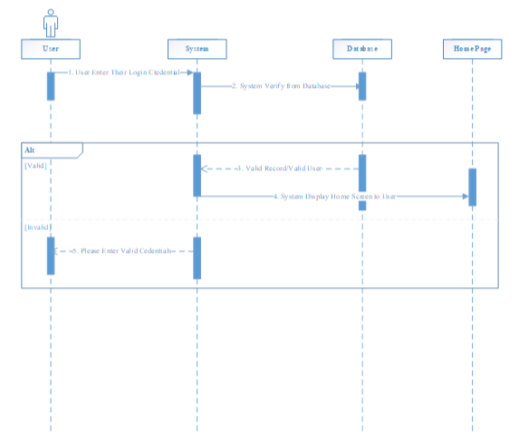

Figure ‎3.3.2: Sequence Diagram for User LogIn

* + 1. **View User Profile/Course**

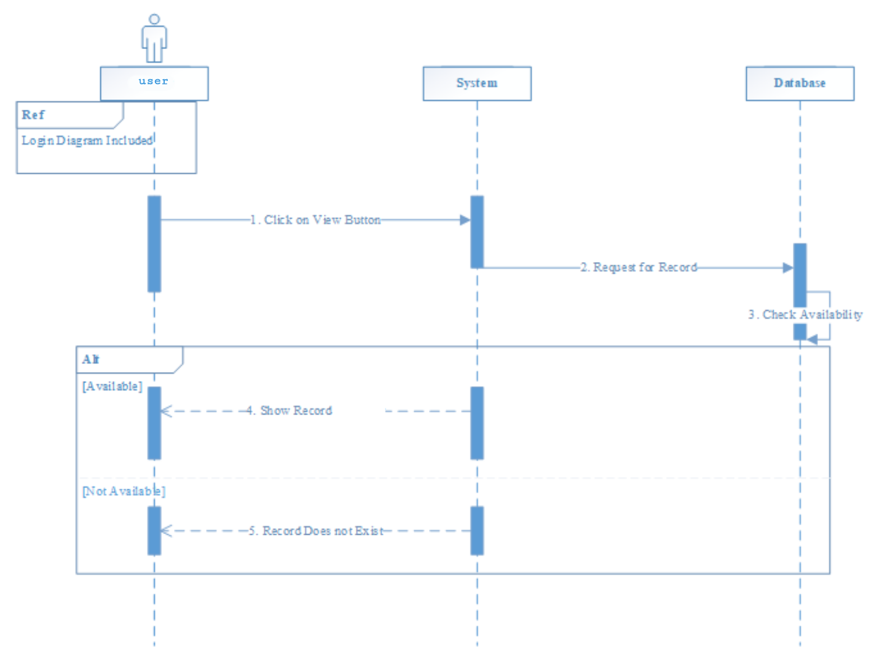

Figure ‎3.3.3: Sequence Diagram for view User

* + 1. **Search User/Course**

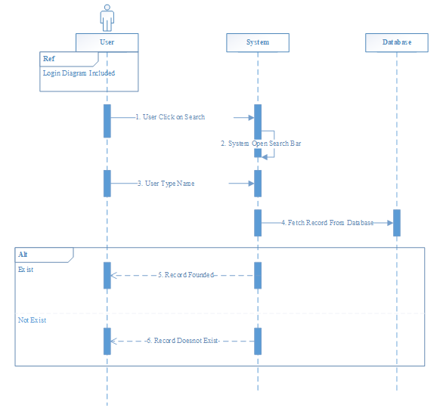

Figure ‎3.3.4: Sequence Diagram for Search User/course

* + 1. **Update**

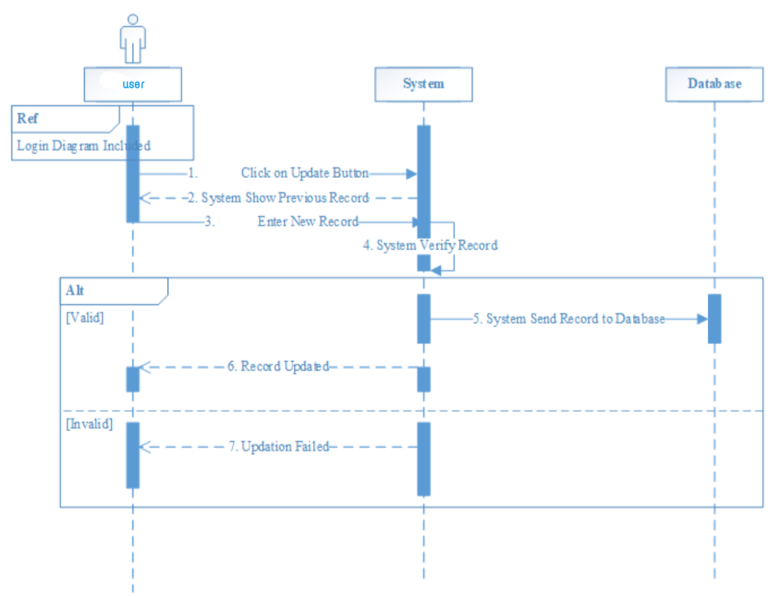

Figure ‎3.3.5: Sequence Diagram for Update

* + 1. **Demo Class**

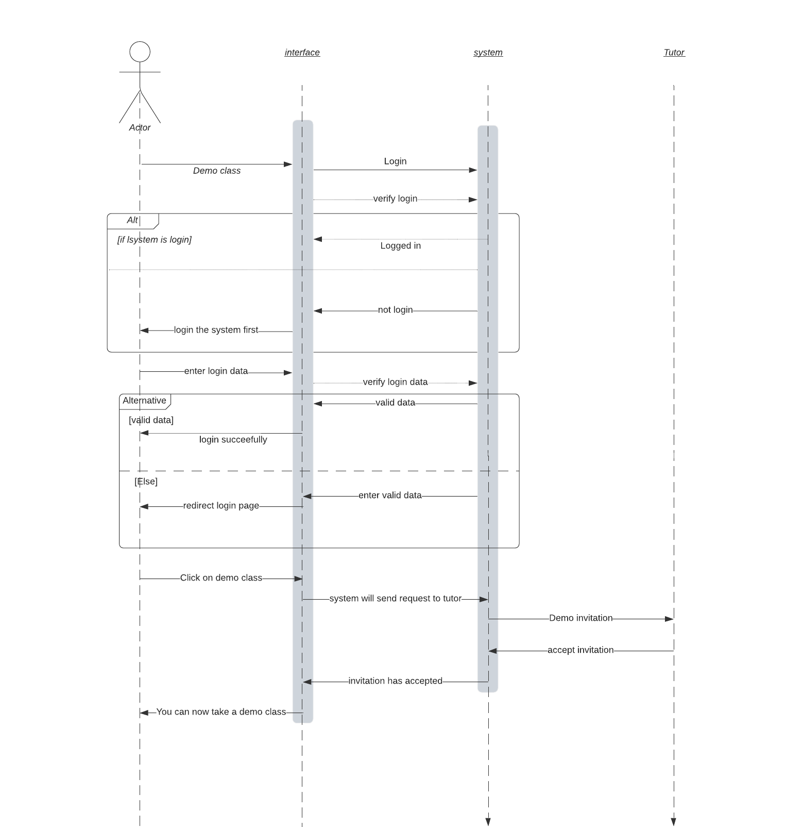

Figure ‎3.3.6: Sequence Diagram for Demo Class

* + 1. **View Payment History**

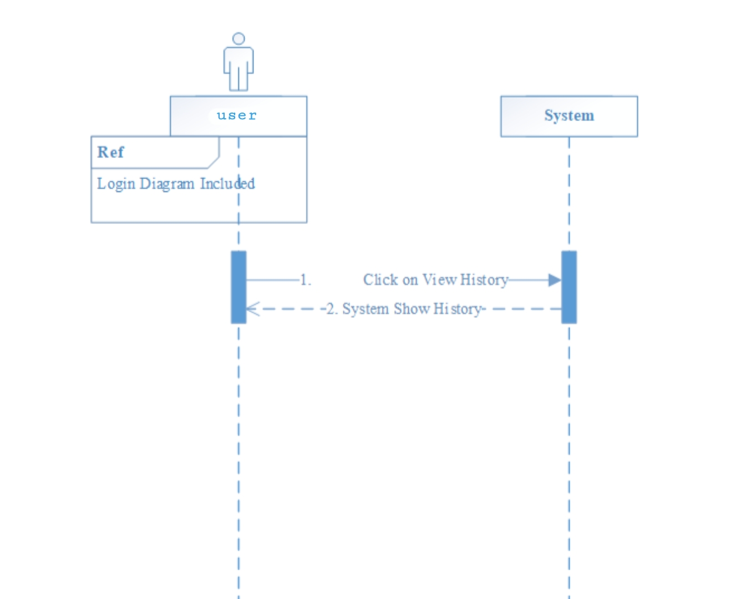

Figure ‎3.3.7: Sequence Diagram for Payment History

* + 1. **Logout**

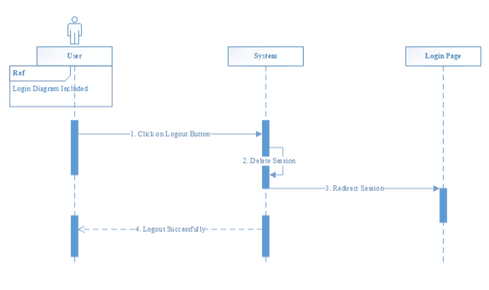

Figure ‎3.3.8: Sequence Diagram for Logout

## ERD

|  |
| --- |
|  |

Figure ‎3.4: ERD of Quran Learning System

Chapter 4

Testing

# Testing

**FOR EXAMPLE:** A software test engineer is involved in the testing of an application and is generally a member of software quality assurance team. Test engineers of this web application were Member 1&Member 2.

## Sign Up Admin

Table ‎4.1: Sign up Test case

|  |  |
| --- | --- |
| **Sign Up Test Case** | |
| Test Engineer | Muhammad Usama Bashir |
| Test Case ID | TC-1 |
| Date | June 20, 2021 |
| Purpose | Signup into system |
| Pre-Req | Signup function |
| Test Data | * User Name , Valid Email and Password , Invalid Email or Password , Check the box of terms |
| Steps | Following steps will take place in test.  Case-1   * Filled the fields of User name: Usama , Email: uxama.ali775@gmail.com, Password password * Click on Sign up button * Sign up successfully   Case-2   * User name , Email or Password are not filled * Click on Sign up button * Response show Please fill the require fields   Case-3   * Enter invalid User Name|| Email || Password * Click on Sign up Button * System show error message invalid data is input please enter valid User Name|| Email || Password   Case-3   * Enter an email which is already used for another account * Response show Email already exists. |
| **Status** | Pass |

* 1. **Login**

Table ‎4.2: Log in Test case

|  |  |
| --- | --- |
| **Login Test Case** | |
| Test Engineer | Muhammad Awais Danish |
| Test Case ID | TC-2 |
| Date | June 20, 2021 |
| Purpose | Logged into system. |
| Pre-Req | Not logged in , must have an account |
| Test Data | * User Name, Email & Password. |
| Steps | Following steps will take place in test.  Case-1   * Filled the valid email address and password * Click on the Sign in button * Successfully login to the system   Case-2   * Email or Password are not filled * Click on Sign in Button * Response show Please fill out this field   Case-3   * Enter an Invalid Email or Password * Click on Sign in Button * Response show Sorry you cannot log in to system |
| **Status** | Pass |

* 1. **Search**

Table .3 Search Test Case

|  |  |
| --- | --- |
| **Search** | |
| Test Engineer | Muhammad Awais Danish |
| Test Case ID | TC-3 |
| Date | June 24, 2021 |
| Purpose | Search |
| Pre-Req | Admin logged into system , Evaluate performance |
| Test Data | * Search Data |
| Steps | Following steps will take place in test.   * Click on Home page * Select category to search * Click on Search button * System will Search the products for user |
| **Status** | Pass |

* 1. **Chat**

Table .4 Chat Test Case

|  |  |
| --- | --- |
| **Chat Test Case** | |
| Test Engineer | Muhammad Awais Danish |
| Test Case ID | TC-4 |
| Date | June 25, 2021 |
| Purpose | Chat |
| Pre-Req | Admin logged into system |
| Test Data | * Chat function |
| Steps | Following steps will take place in test.   * Click on product booking page * Click on Chat option to get further details about the product * A dialogue box will appear for chat |
| **Status** | Pass |

* 1. **View User/Course**

Table .5 View Test Case

|  |  |
| --- | --- |
| **View** | |
| Test Engineer | Muhammad Bilal |
| Test Case ID | TC-8 |
| Date | June 30, 2021 |
| Purpose | View |
| Pre-Req | Admin logged into system |
| Test Data | * View functions |
| Steps | Following steps will take place in test.   * User login or authenticated to the system * User viewed profile |
| **Status** | Pass |

* 1. **Payment History**

*Table 4.6 View Payment*

|  |  |
| --- | --- |
| **View Payment History** | |
| Test Engineer | Usama Bashir |
| Test Case ID | TC-10 |
| Date | July 3, 2021 |
| Purpose | View payment |
| Pre-Req | Admin logged into system , orders are existed |
| Test Data | * View payment history function |
| Steps | Following steps will take place in test.     * User must login to the system * User check the payment history * System shows the payment History |
| **Status** | Pass |

* 1. **Logout**

Table .7 Logout Test Case

|  |  |
| --- | --- |
| **Logout Test Case** | |
| Test Engineer | Usama Bashir |
| Test Case ID | TC-13 |
| Date | July 7, 2021 |
| Purpose | Logout to the system |
| Pre-Req | Login to system |
| Test Data | * Logout function |
| Steps | Following steps will take place in test.   * Click on logout button * Exit from System |
| **Status** | Pass |

Chapter 5

User Manual

# User Manual

## Home Page

At the very first page of the website, user can see navbar and inside navbar there’s a signup and login option for users. Also there is a dropdown menu where learner can check registered tutors.



|  |
| --- |
| Figure ‎5.1: Home Page |
| * 1. **Sign Up**   At this page users can sign up and they provide the data required in fields for signup. Then press on submit button to sign up.    Figure ‎5.2: Signup Page   * 1. **Login**   After sign up users can login with their email and password    Figure ‎5.3: Login Page   * 1. **Learner Dashboard**   After login as learner, you can see learner dashboard   * + 1. **Find Tutor**     2. **View Profile**     3. **Edit Profile**     4. **View Courses**     5. **Payment History** |

Figure ‎5.4: Learner Dashboard

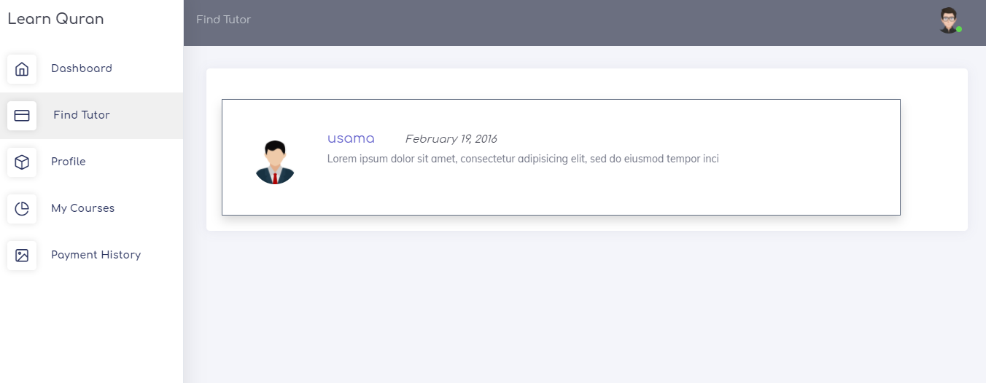

Figure ‎5.4.1: Find Tutor

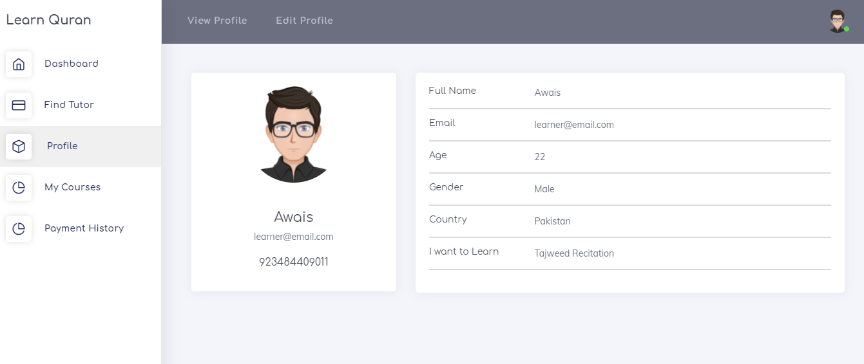

Figure ‎5.4.2: View Profile

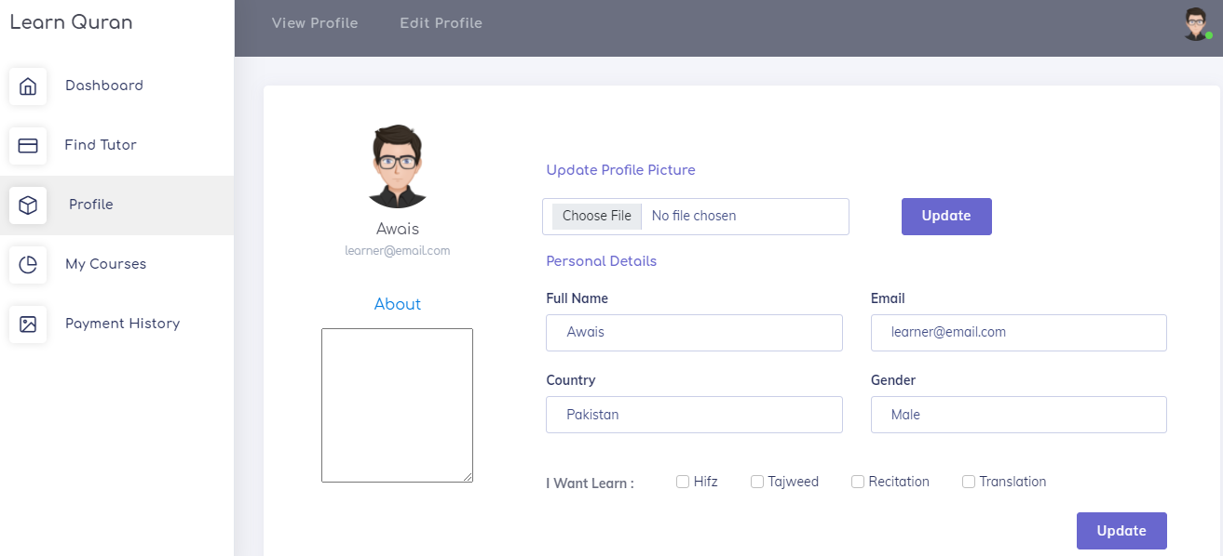

Figure ‎5.4.3: Edit Profile

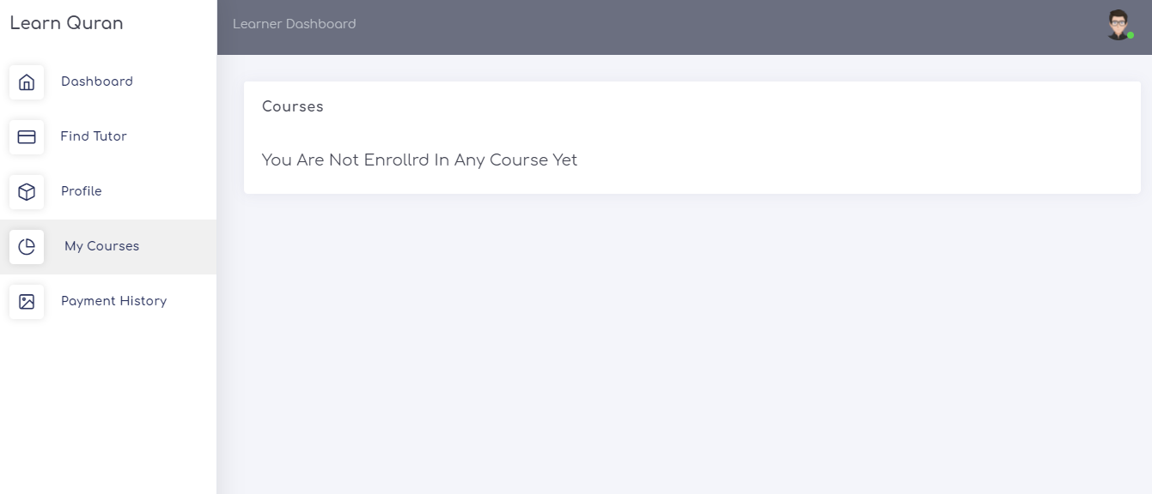

Figure ‎5.4.3: View Enrolled Courses

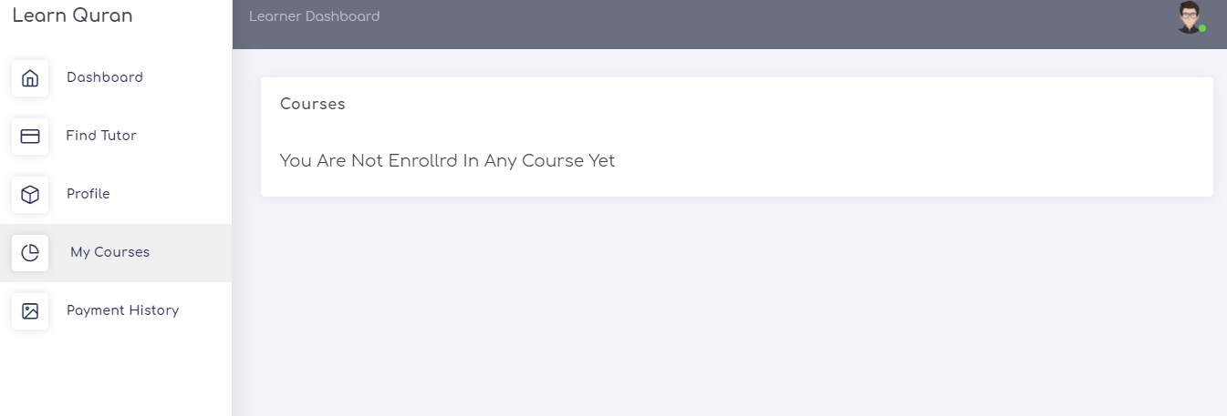

Figure ‎5.4.3: View Enrolled Courses

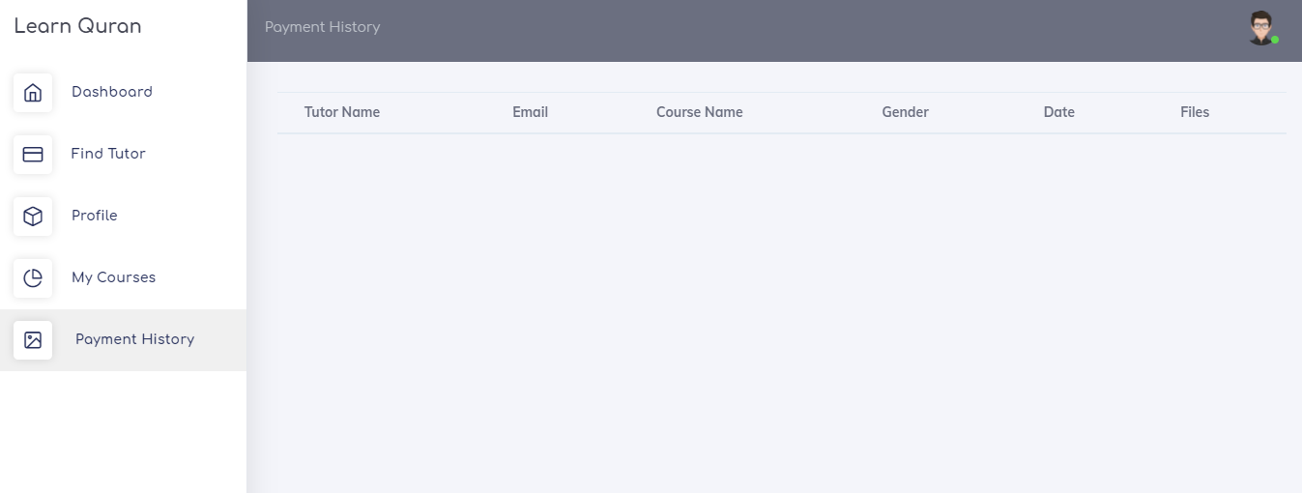

Figure ‎5.4.3: View Payment History

* 1. **Tutor Dashboard**

After Signup as tutor, you can see many options related to tutor. Such as

* + 1. **Find Learner**
    2. **Profile**
    3. **Edit Profile**
    4. **My Course**
    5. **Inventions**
    6. **My Students**
    7. **Payment Receipts**

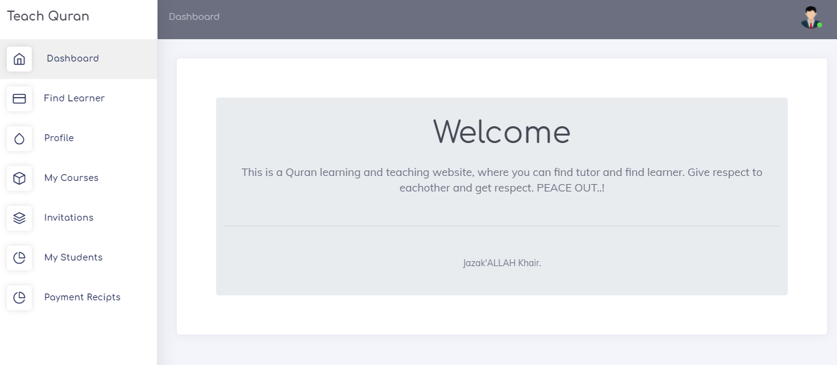

Figure ‎5.4: Tutor Dashboard

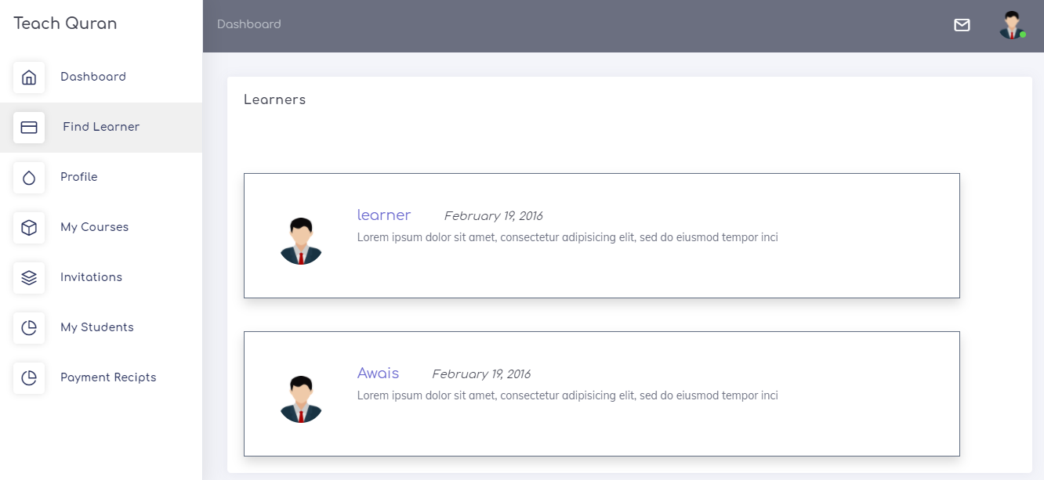

Figure ‎5.5.1: Find Tutor

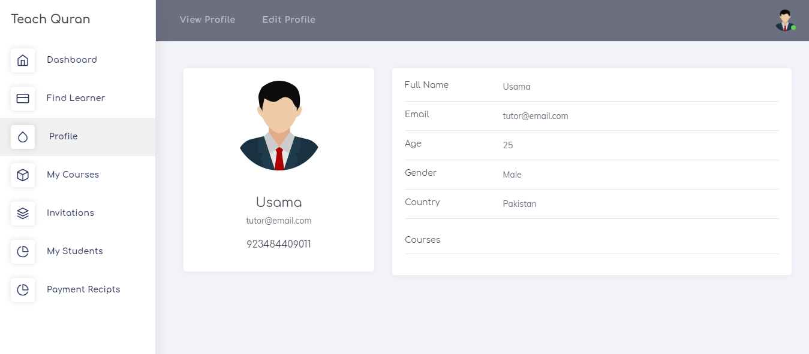

Figure ‎5.5.2: View Profile

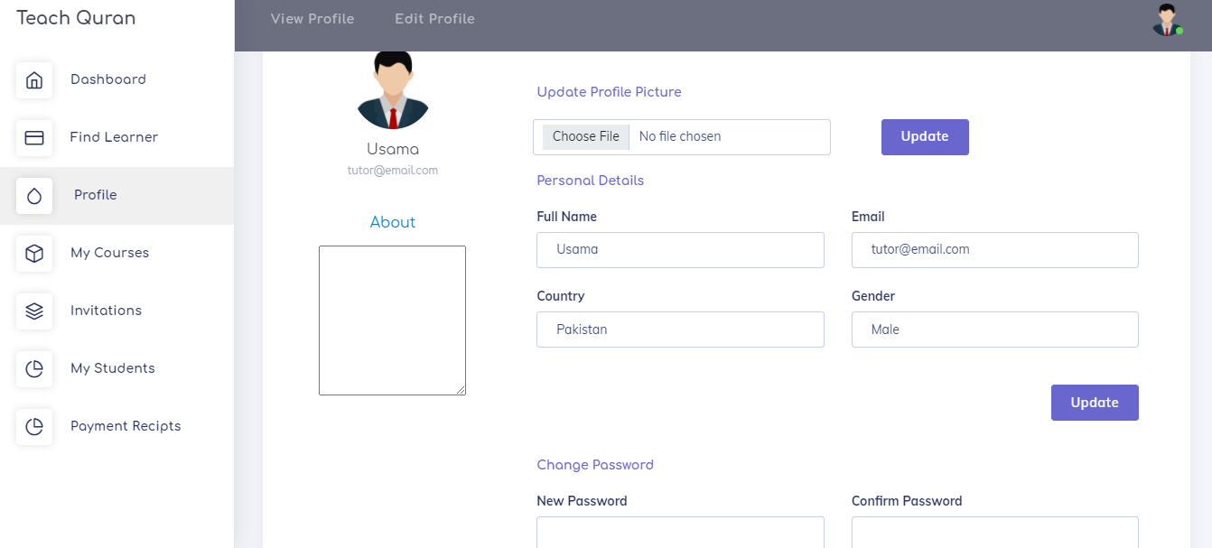

Figure ‎5.5.3: Edit Profile

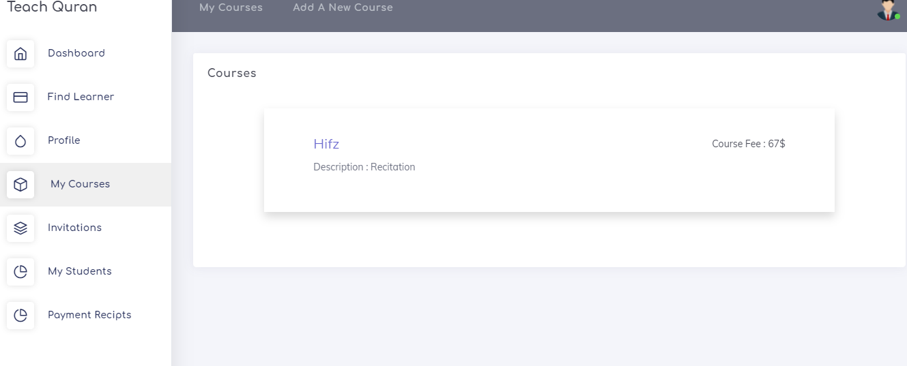

Figure ‎5.5.4: My courses

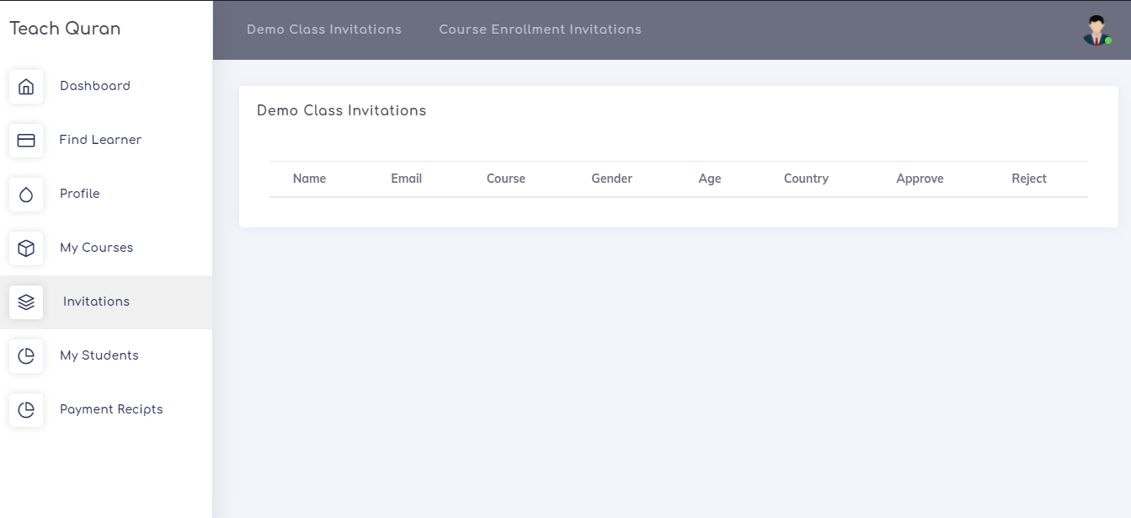

Figure ‎5.5.5: Invitations

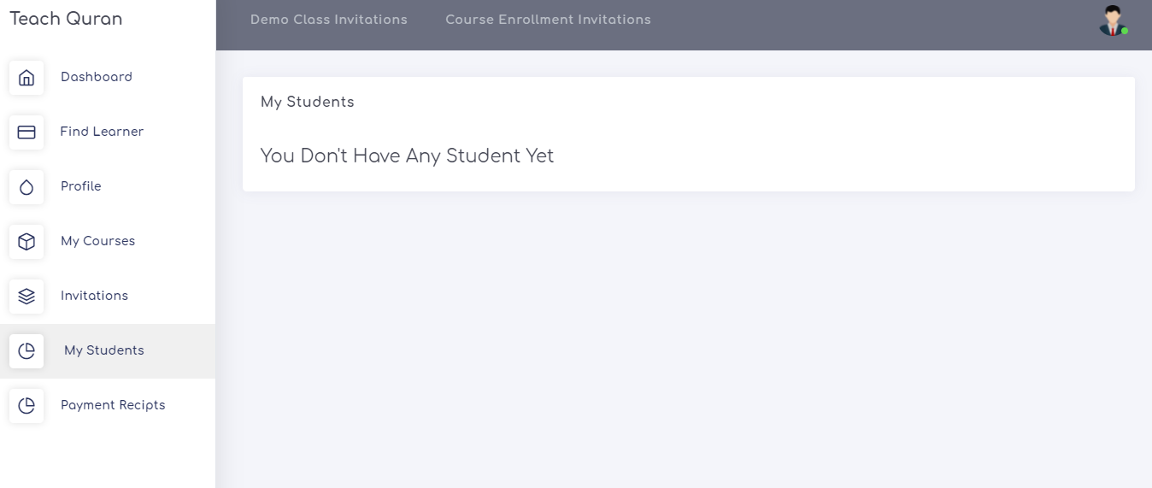

Figure ‎5.5.6: Students

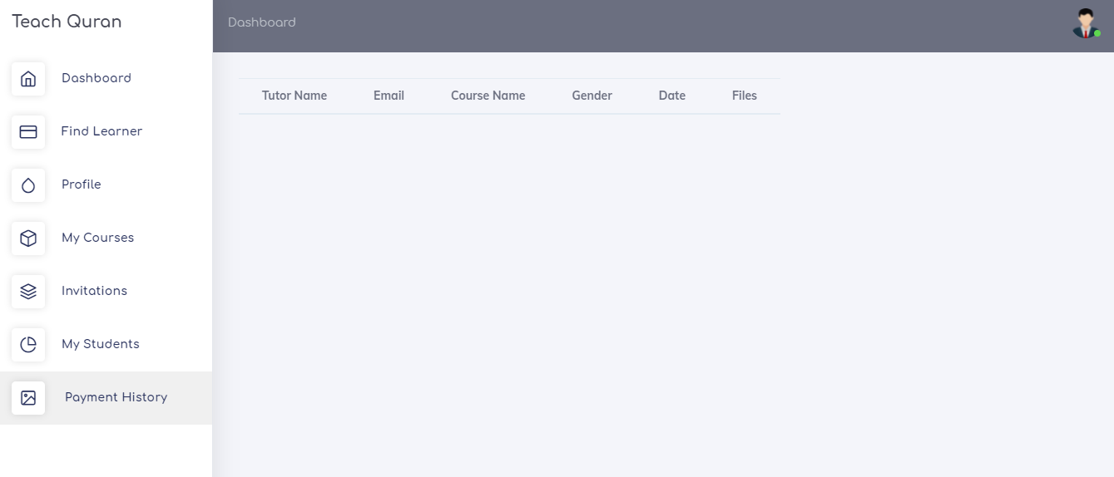

Figure ‎5.5.7: Payment History

* 1. **Admin Dashboard**

Admin can check all the users registered on the websites, view their profiles and delete them.

* + 1. **Learners**
    2. **Tutors**

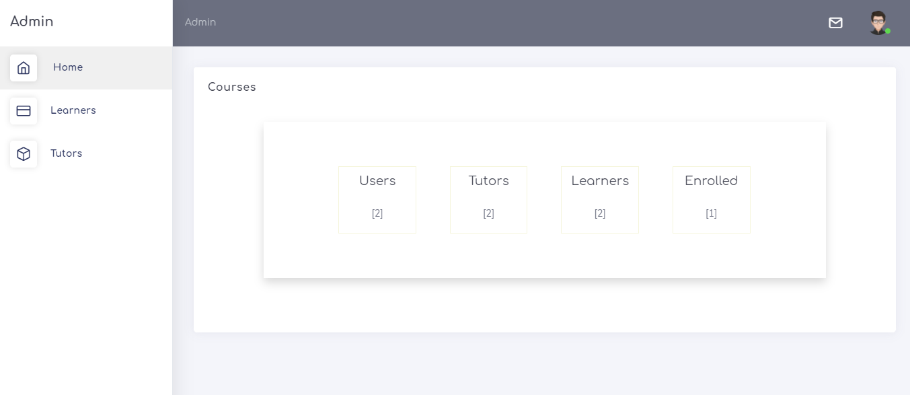

Figure ‎5.6: Admin Dashboard

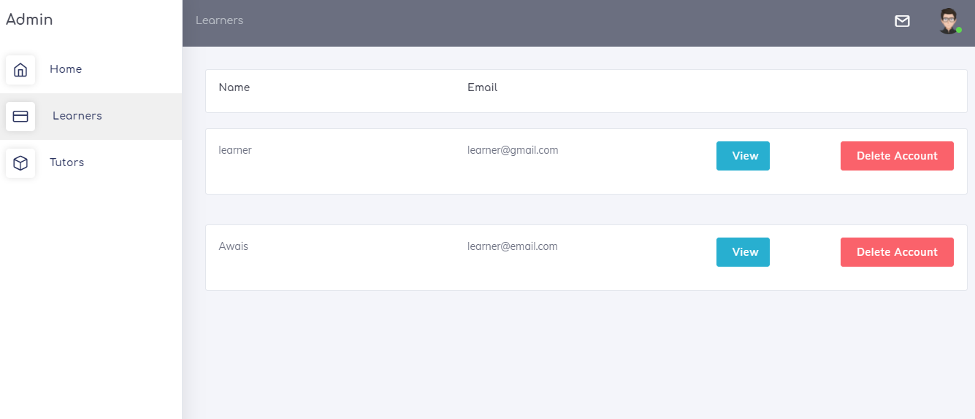

Figure ‎5.6.1: Learners

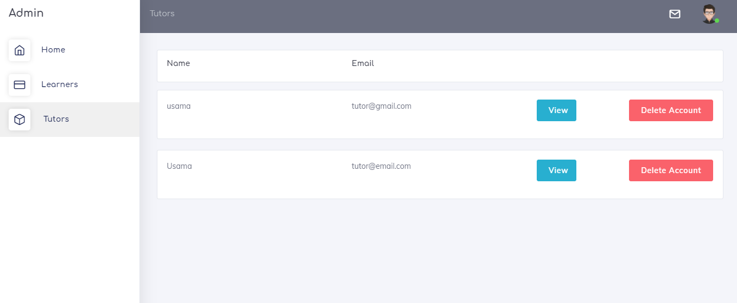

Figure ‎5.6.2: Tutors